# 1 Stoichiometric relationship

## 1.1 Intro to the particulate nature of matter and chemical change

### 1.1.1 The particulate nature of matter

The three states of matter are solid, liquid and gas and these differ in terms of the arrangement and movement of particles.

The particles making up a substance may be individual **atoms** or **molecules** or **ions**.

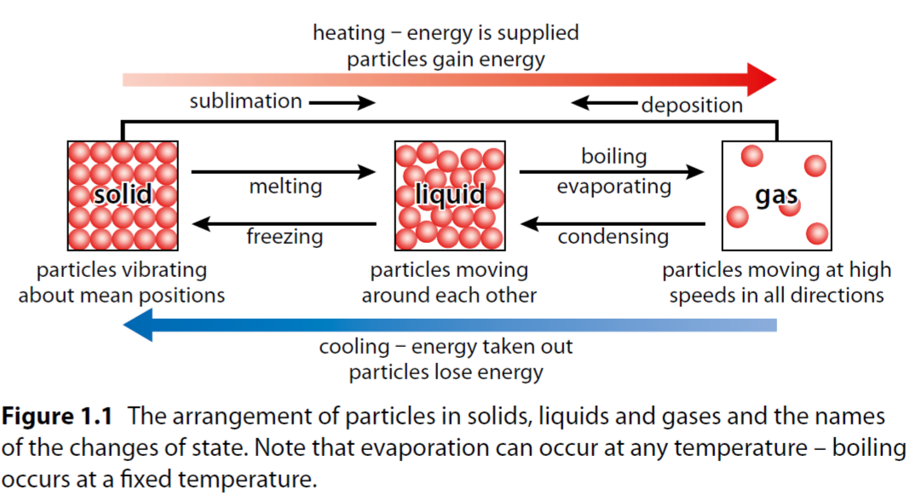

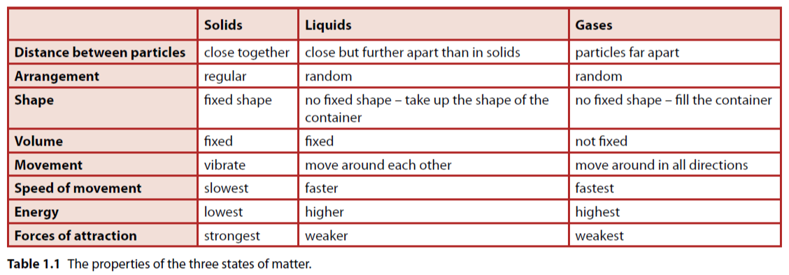

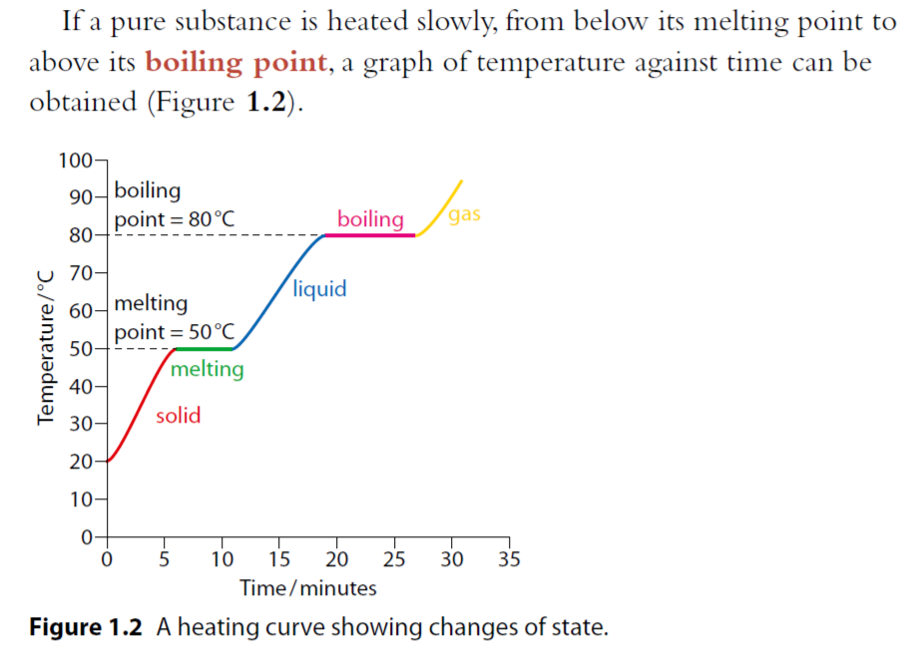

Form 20 °C:

A solid is heated 🡪 particles vibrate more violently 🡪 gain **kinetic energy** 🡪 temperature rises.

At 50 °C:

**Solid and liquid present together**, temperature remains constant. **All the heat energy being supplied is used to partially overcome the forces of attraction** between particles so that they can move around each other.

From 50 °C to 80 °C:

More heat energy 🡪 increasing kinetic energy 🡪 particles in the liquid move around each other more quickly. **The kinetic energy of the particles increases until the boiling point of the liquid is reached.**

At this point (80 °C):

Heat energy is used to overcome the forces of attraction between the particles completely, the temperature of the substance remains constant until all the liquid has been converted to gas.

The continued supply of heat energy increases the kinetic energy of the particles of the gas so they move around faster and faster as the temperature of the gas increases.

1.1.2 Chemical Change

Elements and compounds

Chemistry is partly a study of how chemical elements combine to make

the world and the Universe around us.

An element is a pure substance that contains only one type of

Atom

A compound is a pure substance

formed when two or more

elements combine chemically.

An atom is the smallest part of an element that can still be

recognised as that element.

The physical and chemical properties of a compound are very

different to those of the elements from which it is formed

Chemical properties dictate how something reacts in a chemical

reaction.

Physical properties are basically all the other properties of a

substance – such as melting point, density, hardness, electrical

conductivity etc.

the meaning of chemical equations